EXPERIMENT 1
8 PUZZLE PROBLEM
Aim
To solve the 8-Puzzle problem using a search algorithm and find the shortest path from the initial state to the goal state.
Algorithm
- Start with the initial puzzle state.
- Compare it with the goal state.
- Generate all possible moves by moving the blank tile.
- Select the best state.
- Repeat until the goal state is reached.
- Display the solution path
Flowchart
Start
│
Input Initial State
│
Check Goal State?
│
┌─Yes──► Display Solution ► Stop
│
No
│
Generate Possible Moves
│
Select Best State
│
Repeat

Code and Output

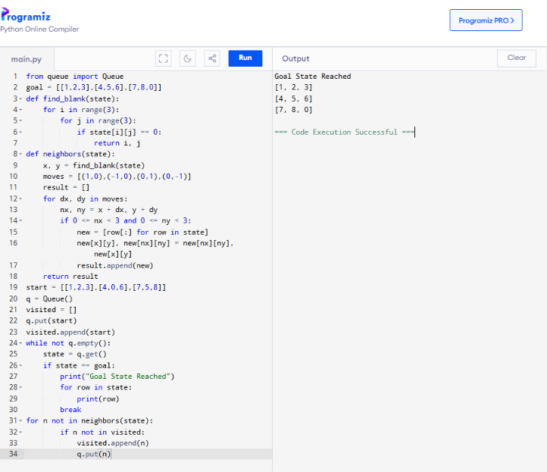
Result
The 8-Puzzle problem is solved successfully and the shortest solution path is displayed.
conclusion
The 8-Puzzle problem was solved successfully using a search algorithm. The program reached the goal state by generating valid moves and finding the correct solution path.

EXPERIMENT 2
8 QUEEN PROBLEM
Aim
To place eight queens on a chessboard so that no two queens attack each other.
Algorithm
  - Start from the first row.
  - Place a queen in a safe column.
  - Move to the next row.
  - If no safe position exists, backtrack.
  - Continue until all queens are placed.
  - Display the board.
Flowchart
Start
│
Place Queen
│
Safe Position?
│ │
No Yes
│ │
Backtrack Next Row
│ │
└────────┘
│
All Queens Placed?
│
Yes
│
Display Board
│
Stop
Code and Output
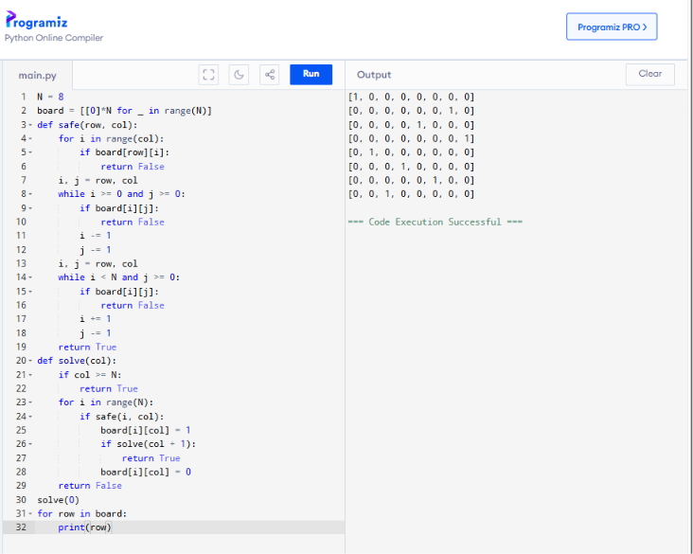

Result
The Crypt-Arithmetic puzzle is solved successfully by assigning valid digits to the letters.
conclusion
The 8-Queen problem was solved successfully using the backtracking algorithm. The program placed all eight queens on the chessboard without any two queens attacking each other.
EXPERIMENT 3
WATER JUG PROBLEM

Aim
To obtain the required quantity of water using two jugs of different capacities
Algorithm
- Fill one jug.
- Pour water into the other jug.
- Empty the filled jug when necessary.
- Repeat filling and pouring.
- Stop when the required quantity is obtained.
Flowchart
Start
│
Fill Jug
│
Pour Water
│
Required Amount?
│ │
No Yes
│ │
Repeat Display Result
│ │
└────────► Stop

Code and Output
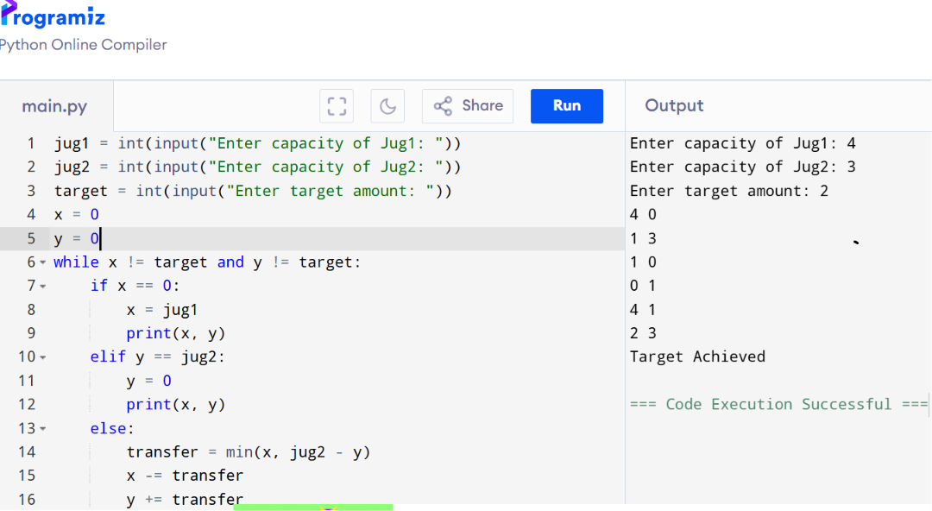
RESULT
The required quantity of water is obtained successfully.
CONCLUSION
The Water Jug problem was solved successfully by performing fill, pour, and empty operations. The program obtained the required quantity of water in the jug.

EXPERIMENT 4
CRYPT ARITHMETIC PROBLEM
AIM
To assign unique digits to letters so that the arithmetic equation is satisfied
ALGORUTHM
  - Read the words in the equation.
  - Identify unique letters.
  - Assign digits (0–9) uniquely.
  - Check if the arithmetic equation is valid.
  - If valid, display the solution.
  - Otherwise, try another assignment.
FLOWCHART
Start
│
Read Equation
│
Assign Digits
│
Equation Valid?
│ │
No Yes
│ │
Try Again Display Solution
│ │
└────────► Stop

Code and Output
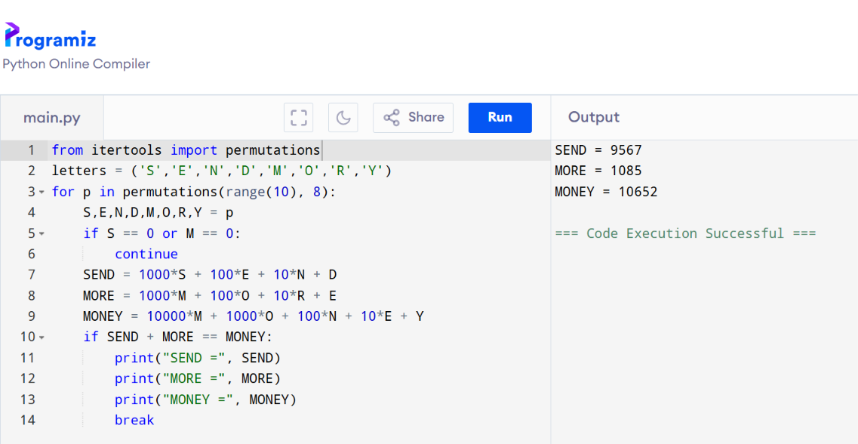

RESULT
The Crypt-Arithmetic puzzle is solved successfully by assigning valid digits to the letters.

CONCLUSION
The Crypt-Arithmetic problem was solved successfully by assigning unique digits to letters. The program found a valid digit assignment that satisfied the given arithmetic equation.

